41.53: The potential 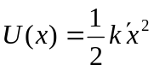 is that of a simple harmonic oscillator. Treated quantum mechanically (see Section 40.4) each energy state has energy 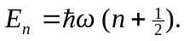 Since electrons obey the exclusion principle, this allows us to put two electrons (one for each 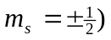 for every value of n⎯each quantum state is then defined by the ordered pair of quantum numbers 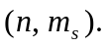
By placing two electrons in each energy level the lowest energy is then
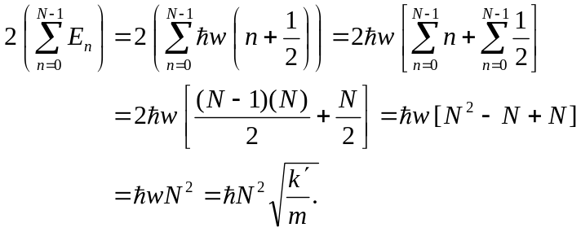
Here we used the hint from Problem 41.51 to do the first sum, realizing that the first value of n is zero and the last value of n is N – 1, giving us a total of N energy levels filled.

